Docker challenge
- Create a customized Docker image using a Dockerfile.
So lets first create a Dockerfile, Using command
- vi Dockerfile →FROM alpine:3.10
- MAINTAINER Techie_Horizon
- RUN mkdir /usr/local/tomcat/
- WORKDIR /usr/local/tomcat
- RUN apk --no-cache add curl && \
- apk add --update curl && \
- curl -O https://dlcdn.apache.org/tomcat/tomcat-9/v9.0.73/bin/apache-tomcat-9.0.73.tar.gz
- RUN tar -xvf apache*.tar.gz
- RUN mv apache-tomcat-9.0.73/* /usr/local/tomcat/.
- RUN rm -rf apache-*
- COPY sample.war /usr/local/tomcat/webapps
- RUN apk update && apk add openjdk8
  - WORKDIR /usr/local/tomcat
  - EXPOSE 8080
- CMD ["/usr/local/tomcat/bin/catalina.sh", "run"]
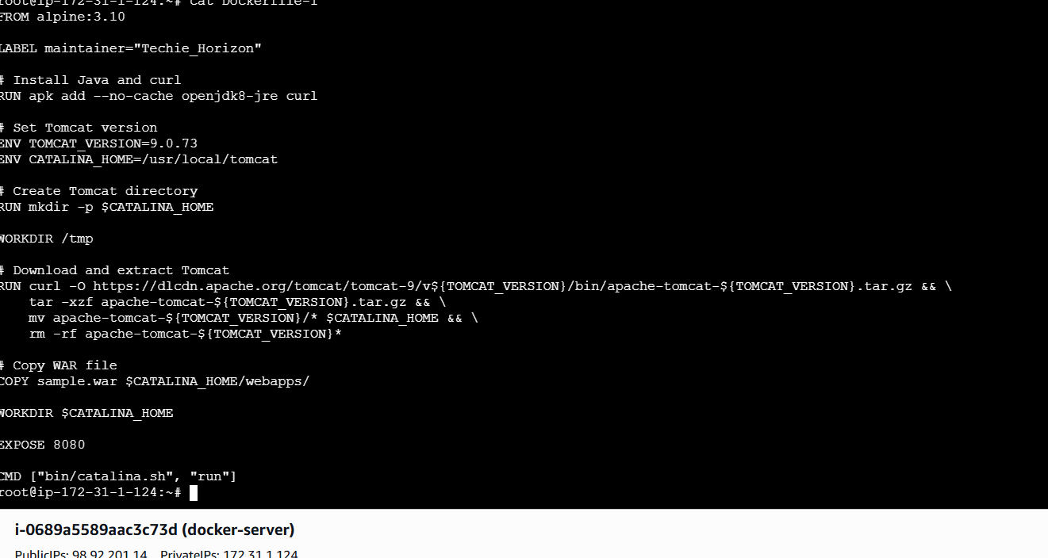
Now lets create the image from Docker file
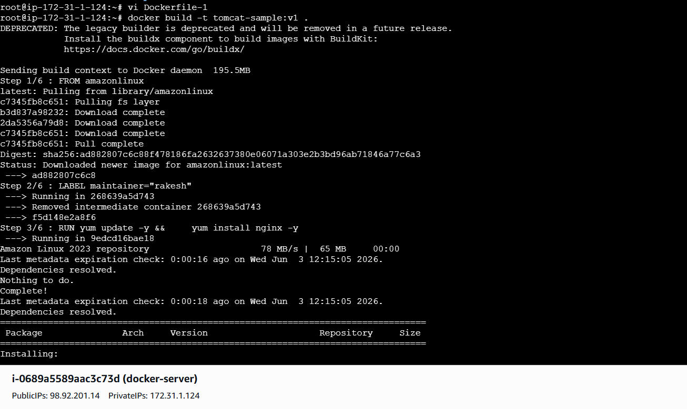
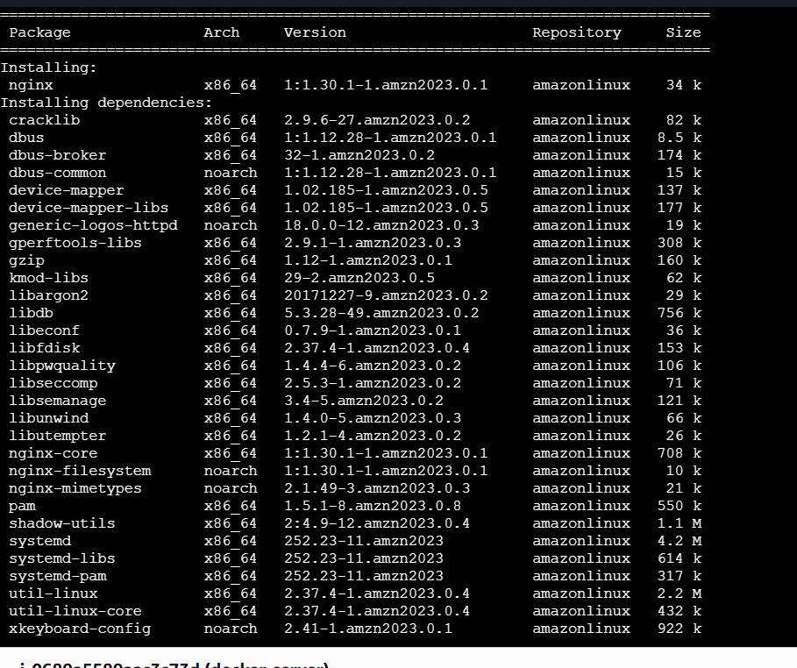
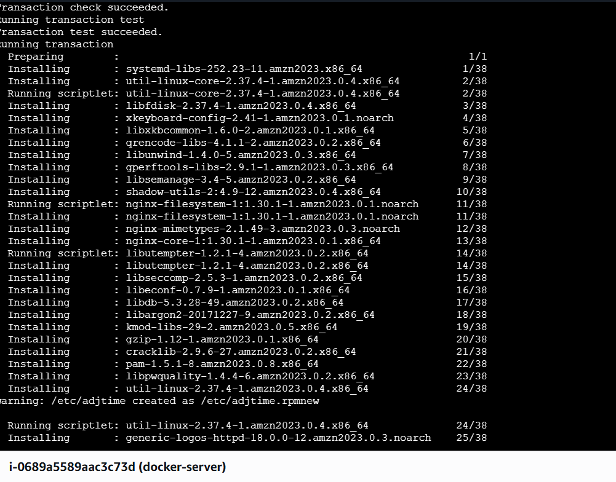
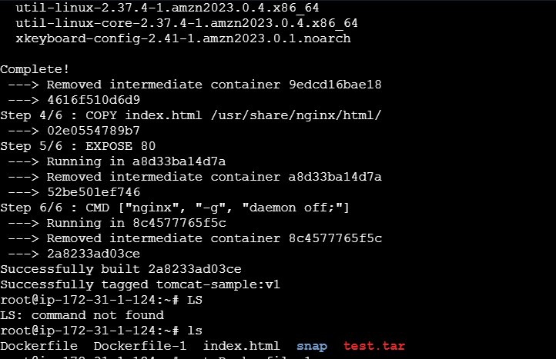
By using dockerfile a new image has been created
docker images
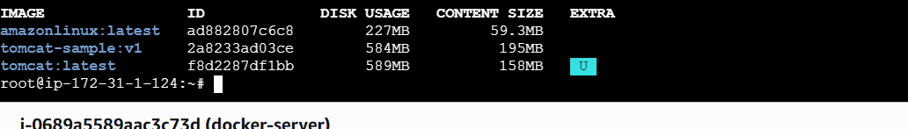
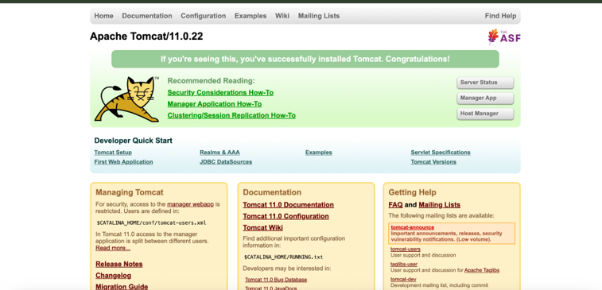

- Push the image to Docker Hub.
Create a repo in Docker hub
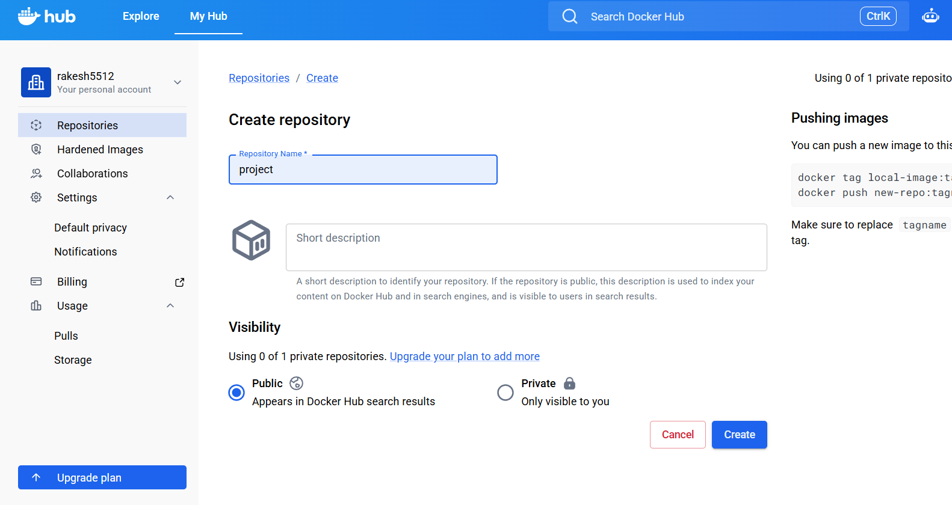
Now lets rename our image name by using command
docker tag rakesh:v1 rakesh5512/project:v1and to push the image to repository use the
command
docker push rakesh5512/project:v1
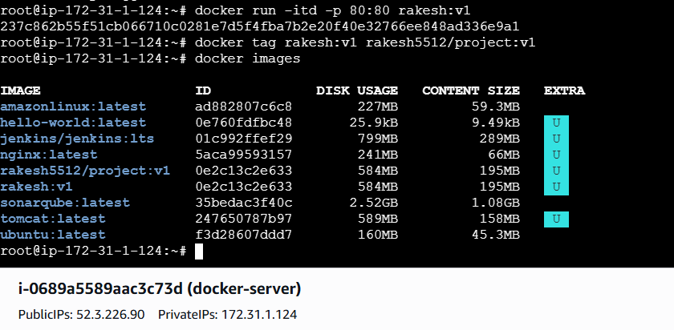
Now lets check in the Docker Hub
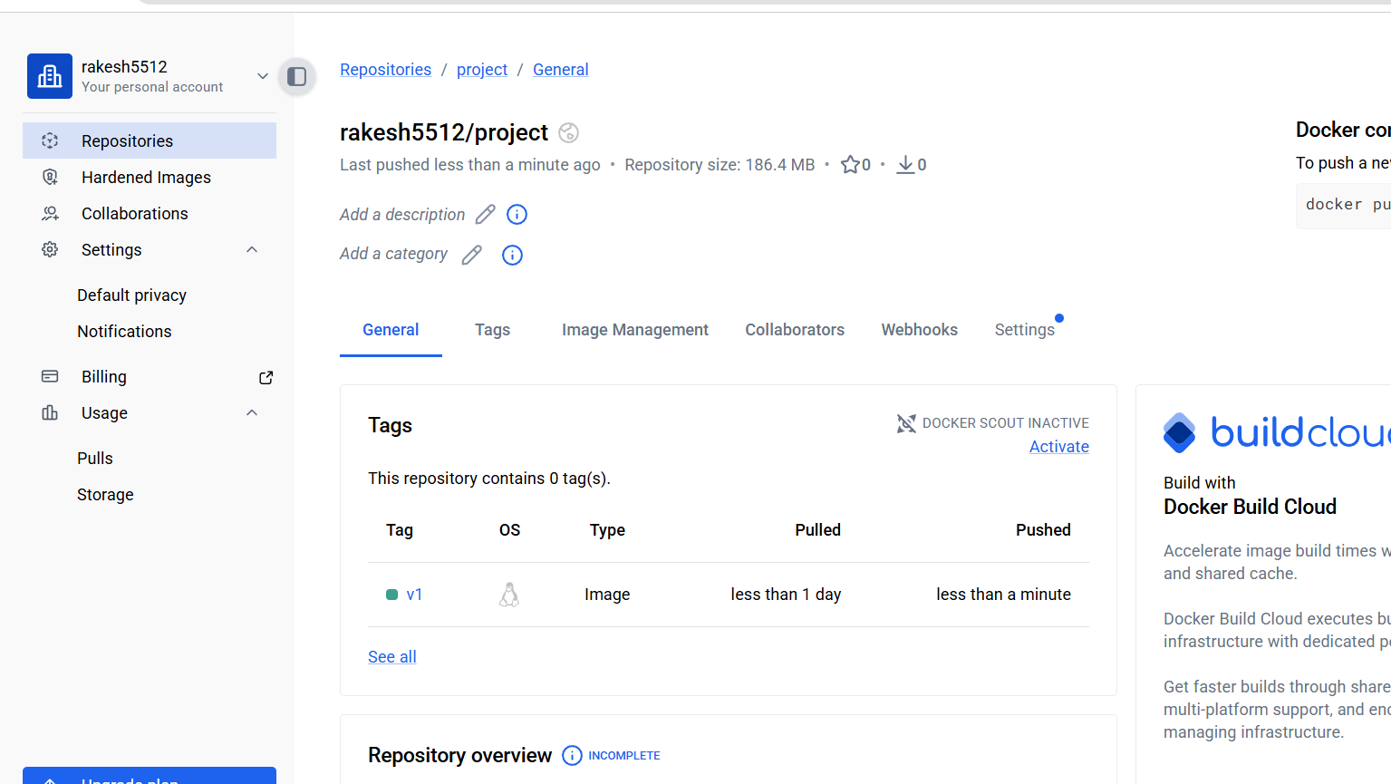

- push image to AWS ECR
Lets create a repo in ECR
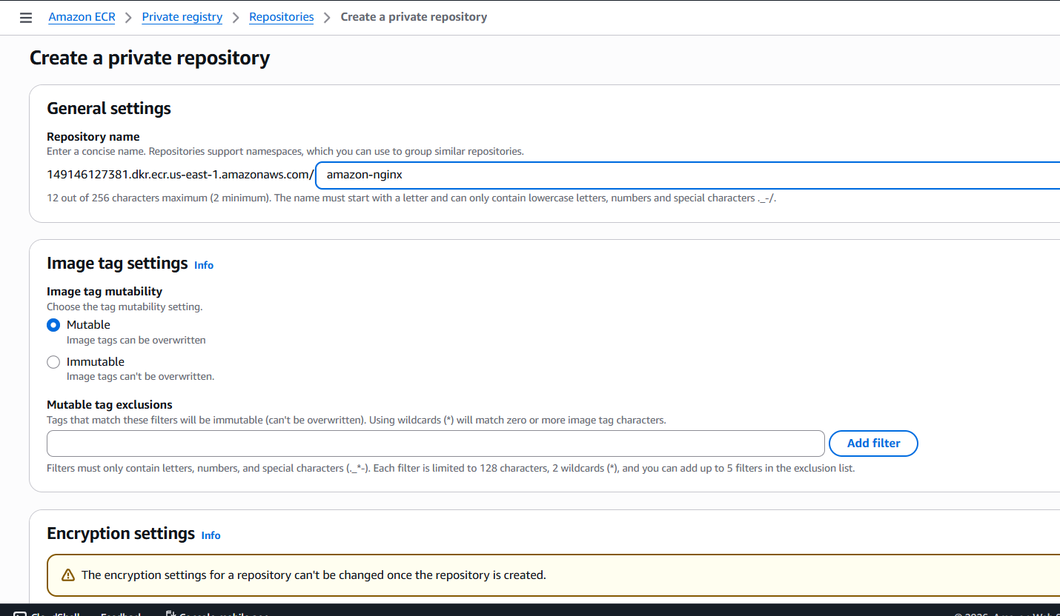
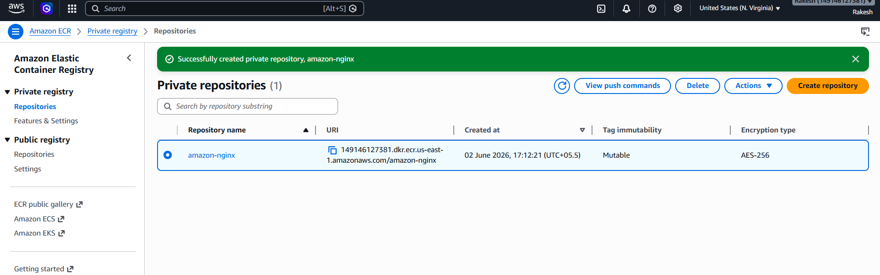
Install AWS CLI using command
apt install awscli -y

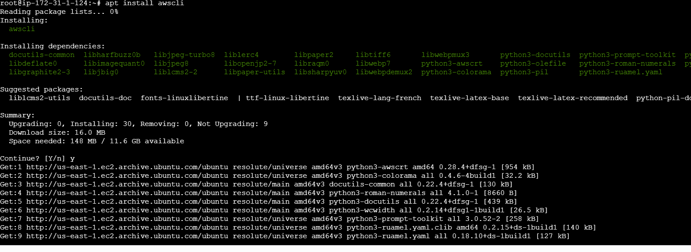
Aws configure
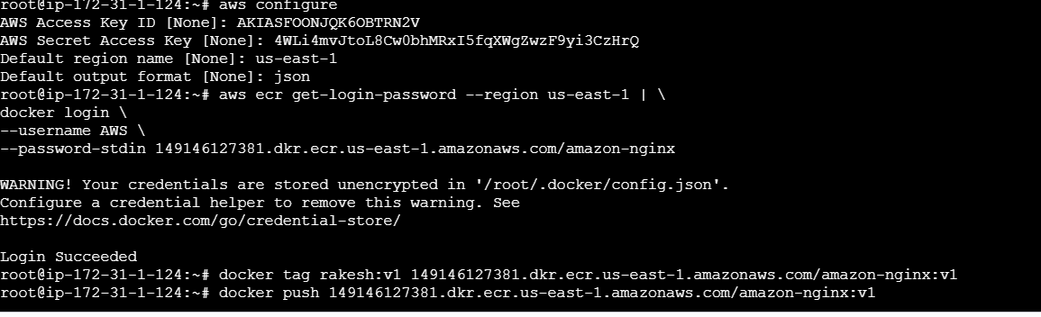
Login using the below command
aws ecr get-login-password --region us-east-1 | \
docker login \
--username AWS \
--password-stdin
149146127381.dkr.ecr.us-east-1.amazonaws.com/amazon-nginx --
U willget this from the URI in the below image
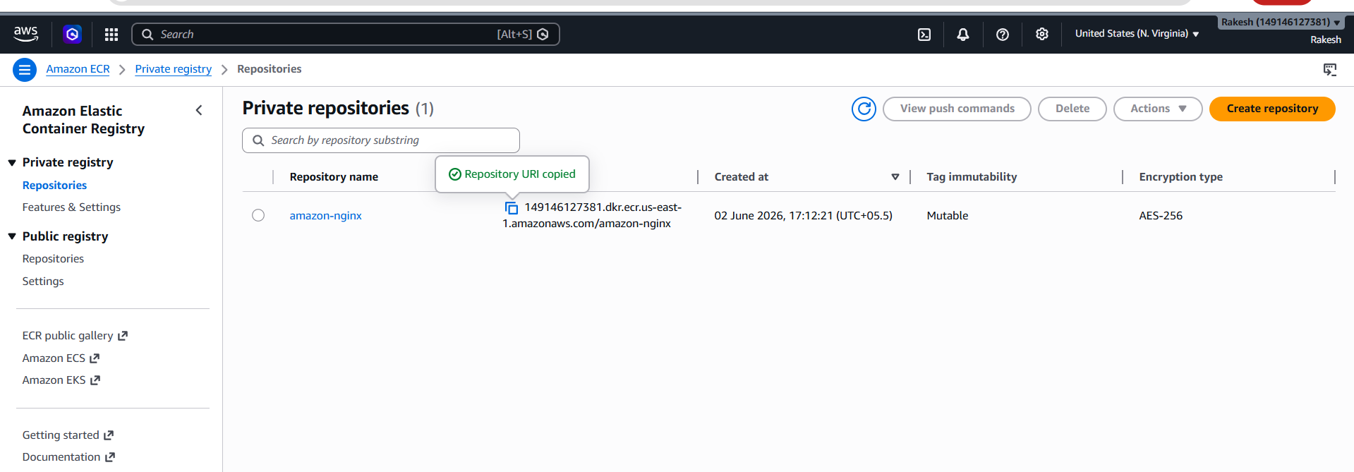
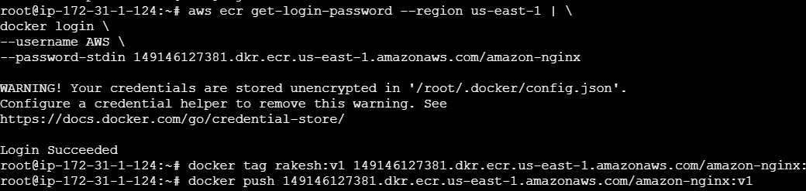
Now lets rename our image to repo name by using command
docker tag rakesh:v1 149146127381.dkr.ecr.us-east-1.amazonaws.com/amazon-nginx:v1
Now lets push to our ECR repo by using command
docker push 149146127381.dkr.ecr.us-east-1.amazonaws.com/amazon-nginx:v1
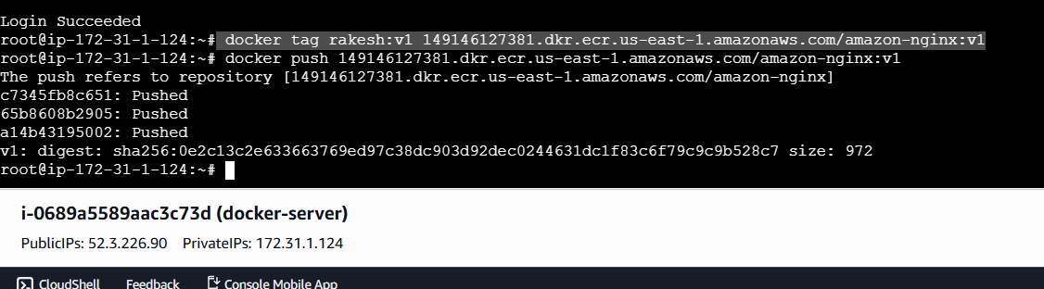

Lets check in the AWS ECR
It has been pushed successfully
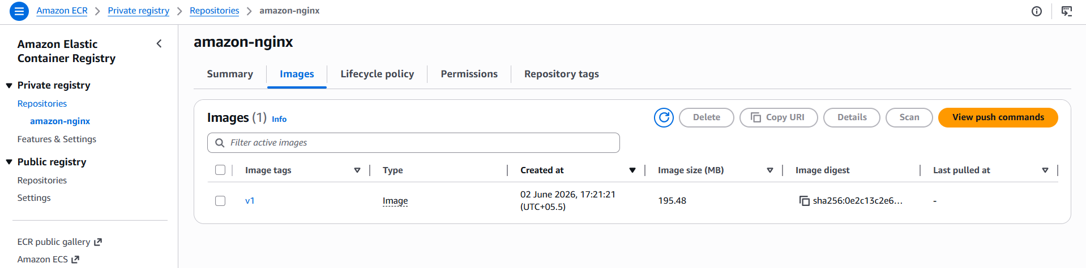

- Create one Jenkins job to build and push the Docker image to Docker Hub.
- Source:https://github.com/betawins/Python-app.git

Source Codes: https://github.com/betawins/docker-tasks.git
- From the frontend source code, write a Dockerfile, build a Docker image, run it, and push that image to your Docker registry.
First Lets clone the data to our machine using
Git clone
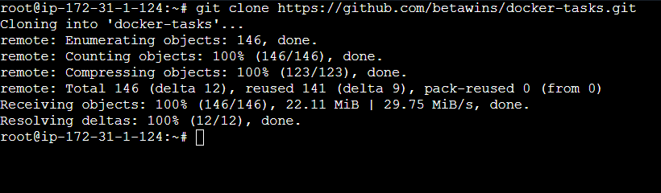
After clone →ls→cd docker-tasks→ls→cd frontend_based_source→ls
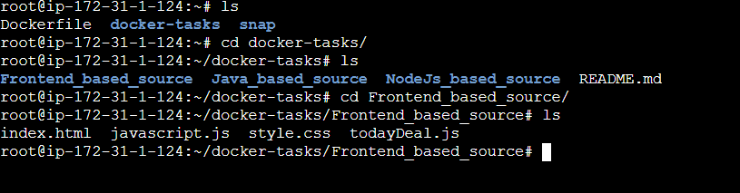
Now lets create a vi Dockerfile
FROM nginx:alpine

COPY . /usr/share/nginx/html

EXPOSE 80

CMD ["nginx", "-g", "daemon off;"]

Why this Dockerfile?
- FROM node:18-alpine → lightweight Node.js image
- WORKDIR /app → creates working directory inside container
- COPY package*.json ./ → copies dependency files first for caching
- RUN npm install → installs required packages
- COPY . . → copies source code
- EXPOSE 3000 → exposes frontend app port
- CMD ["npm", "start"] → starts frontend app

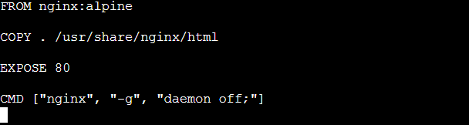
This docker file downloads the latest nginx image and copies all the files from current
directory to /usr/share/nginx/html
Lets now build the image using command
docker build -t frontend-app:v1 .
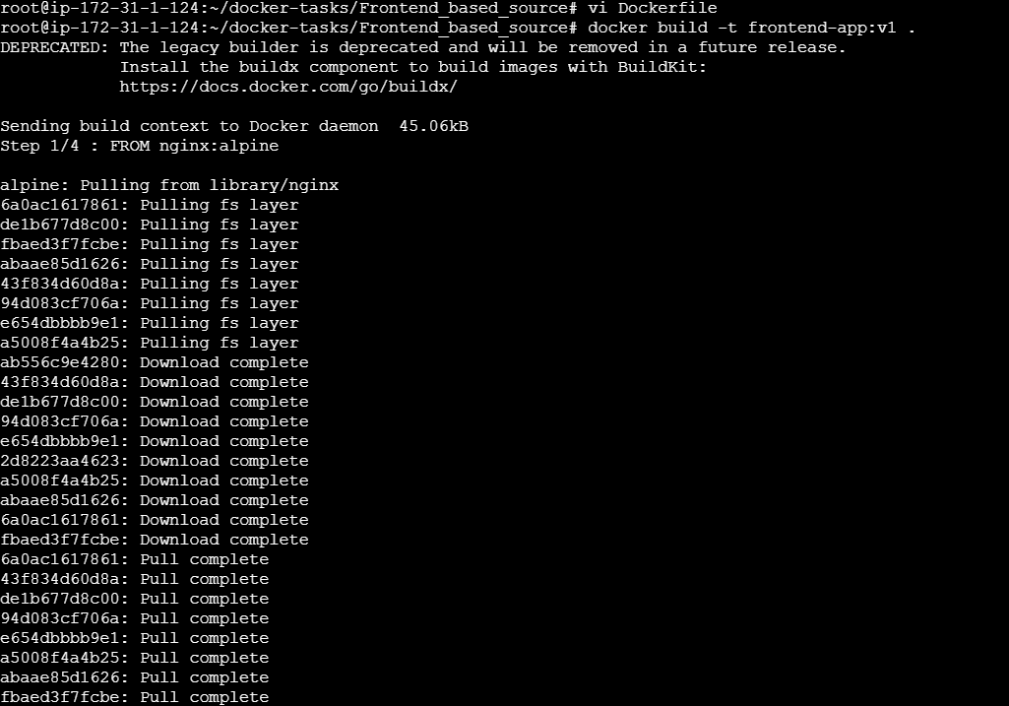
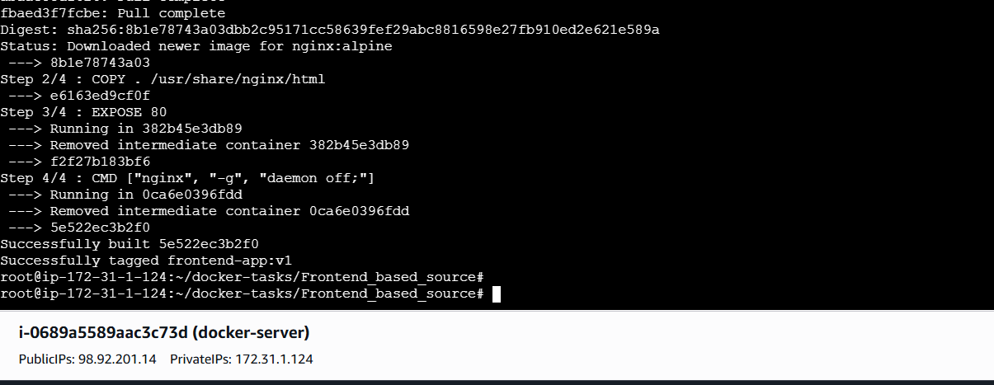
Docker images
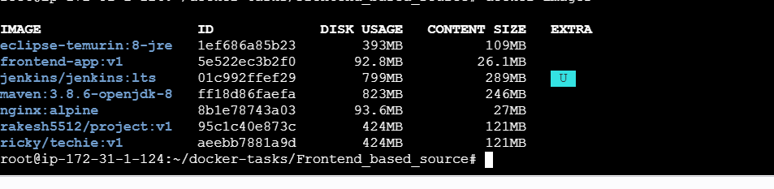
Run the container
docker run -d --name frontend-container -p 8086:80 frontend-app:v1

And Docker ps

Lets check if its Access in Browser


Lets push it to docker hub
Create a repo
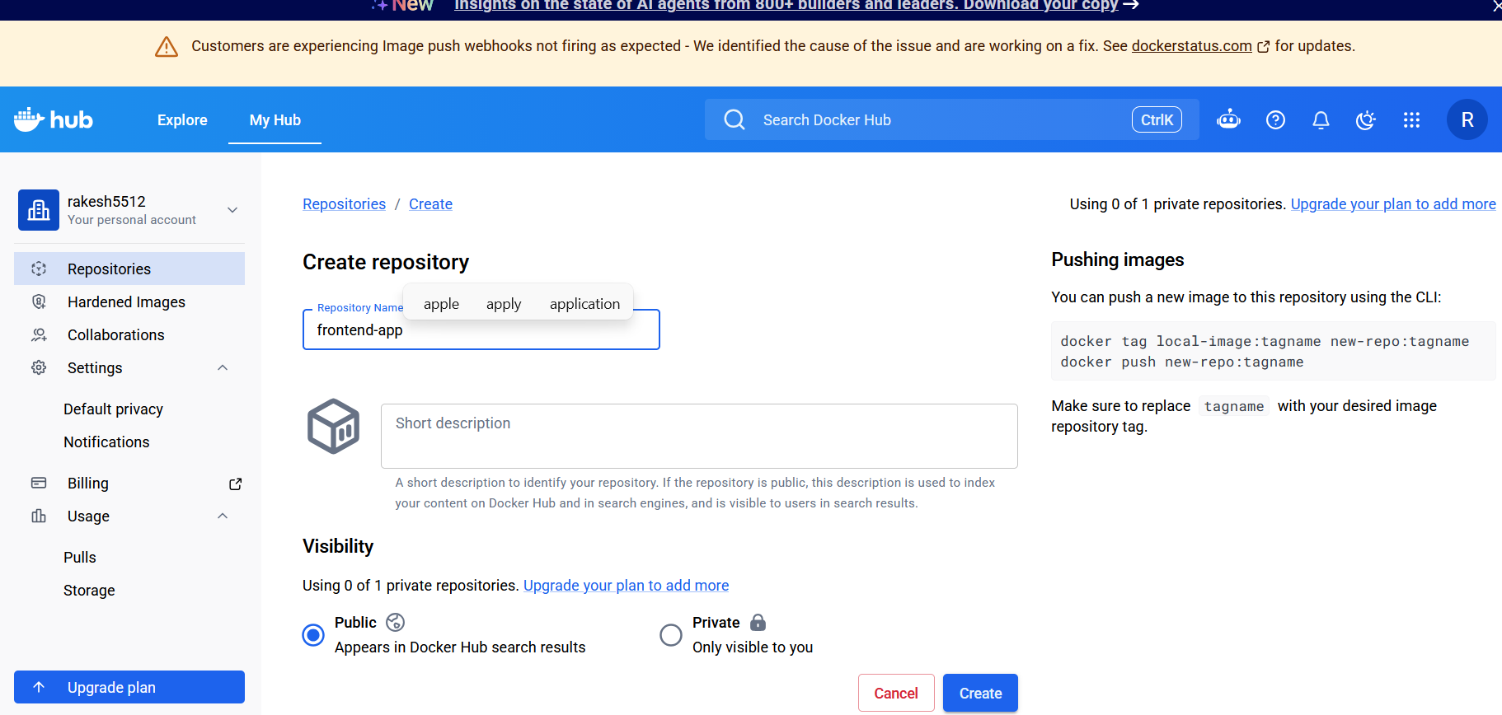
docker tag frontend-app:v1 rakesh5512/frontend-app:v1

docker push rakesh5512/frontend-app:v1
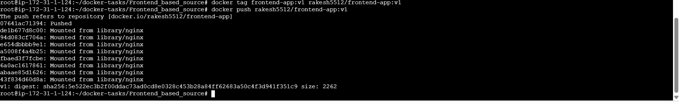
Now lets check in docker hub
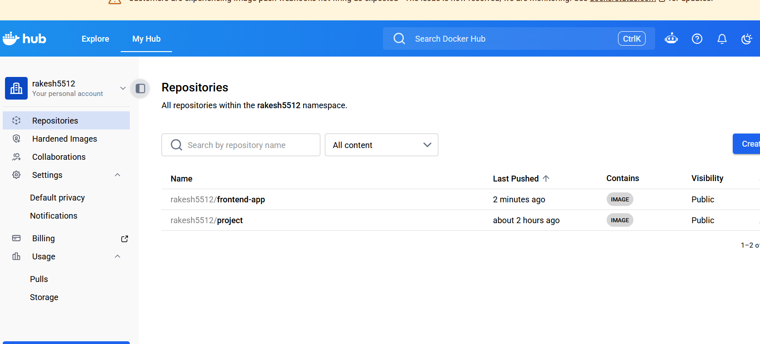pushed successfully
From theJava-based source code, write a Dockerfile, build, run, and push the image to the Docker registry.
Now let’s do the Java-based source code properly.
First go into the Java project:
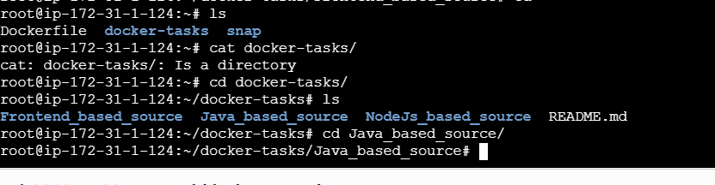

Create a dockerfile using → vi Dockerfile
# Use Maven to build application
FROM maven:3.9.6-eclipse-temurin-17 AS build

WORKDIR /app

COPY . .

RUN mvn clean package -DskipTests

# Runtime image
FROM eclipse-temurin:17-jdk-alpine

WORKDIR /app

COPY --from=build /app/target/*.jar app.jar

EXPOSE 8080

CMD ["java", "-jar", "app.jar"]

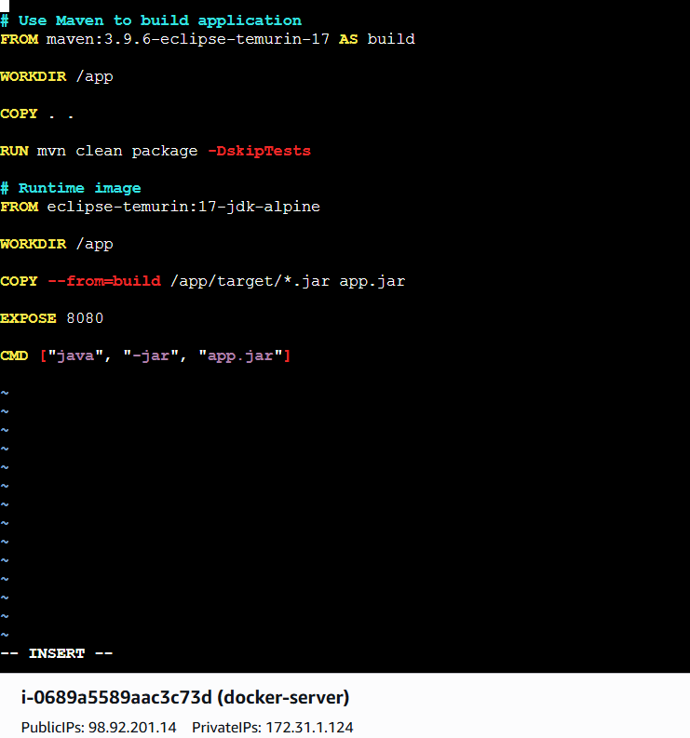
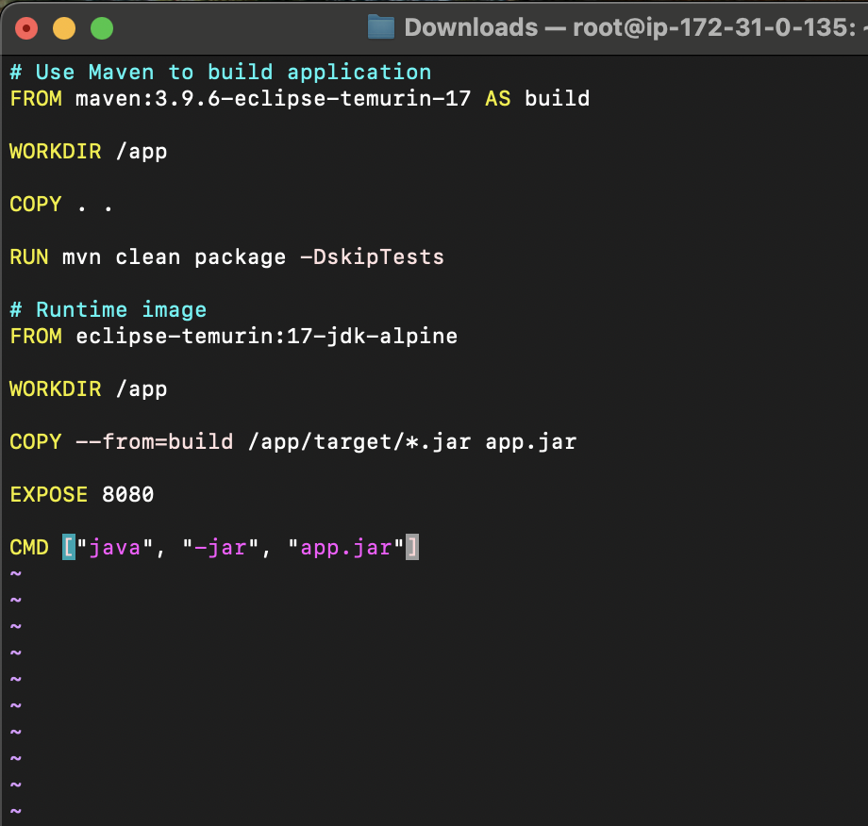
This Dockerfile is a multi-stage Dockerfile used to build and run the Java application efficiently. In the first stage, it uses a Docker image with Maven and Java to build the project and generate the JAR file. It creates a working directory called /app and copies all project files into the container. After building the application, the second stage uses a smaller Java runtime image to reduce image size. It copies only the generated JAR file from the build stage and exposes port 8080 to access the application. Finally, it starts the application using the command java -jar app.jar. This approach makes the Docker image smaller, cleaner, and efficient.
Lets build the image using command
docker build -t java-app:v1 .
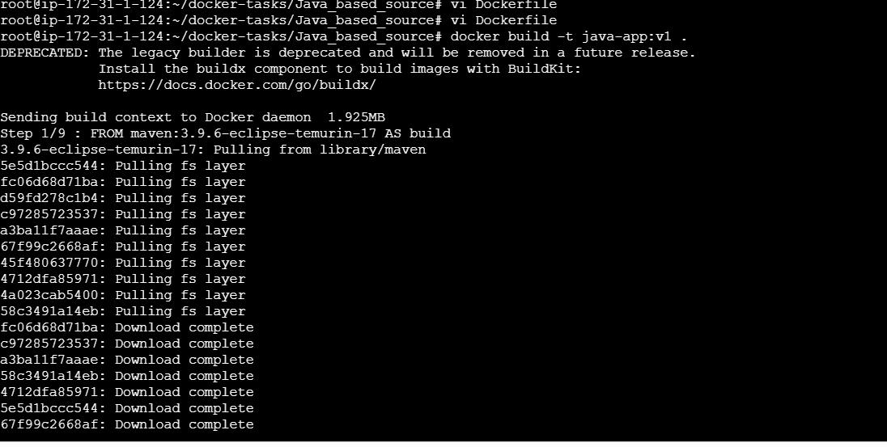

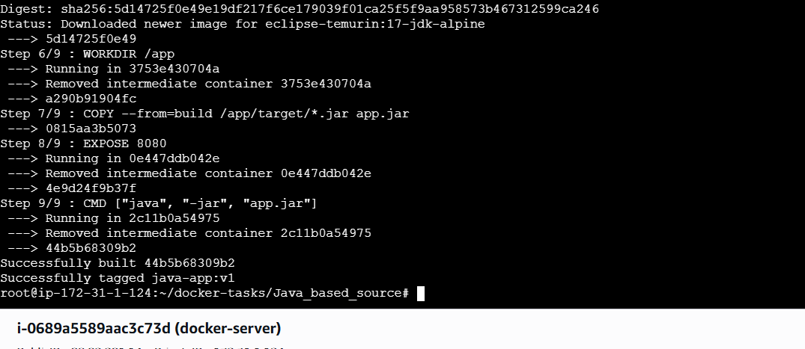
Build Successfull
docker run -d --name java-container -p 8087:8080 java-app:v1
docker images
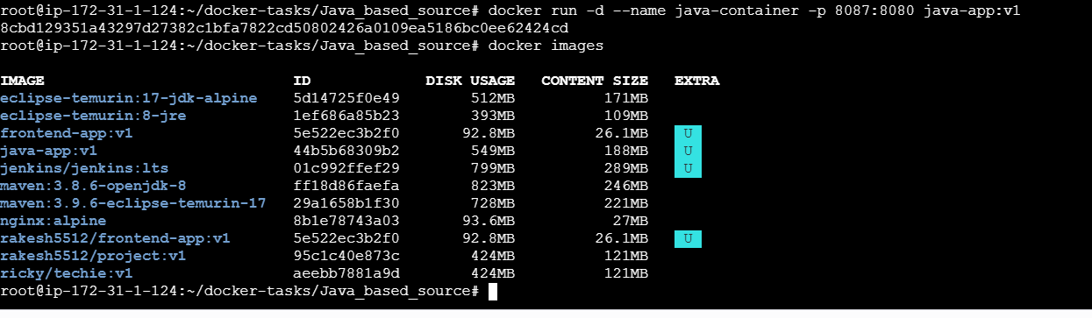
Let's check if we can access in browser
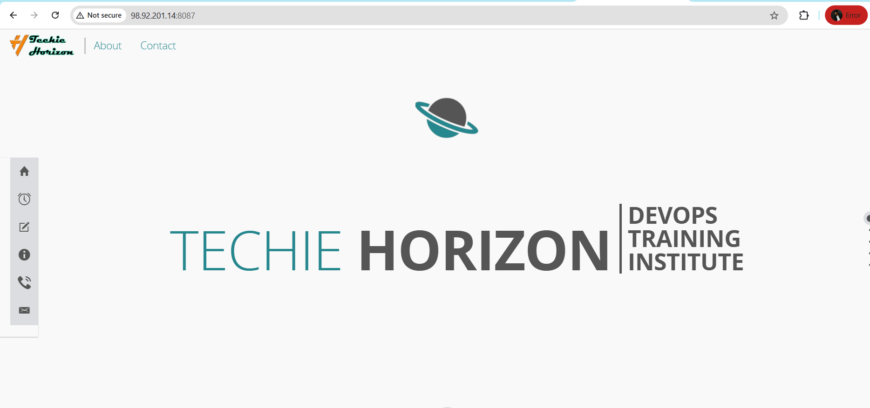
Lets push to DockerHub
Create a new repo
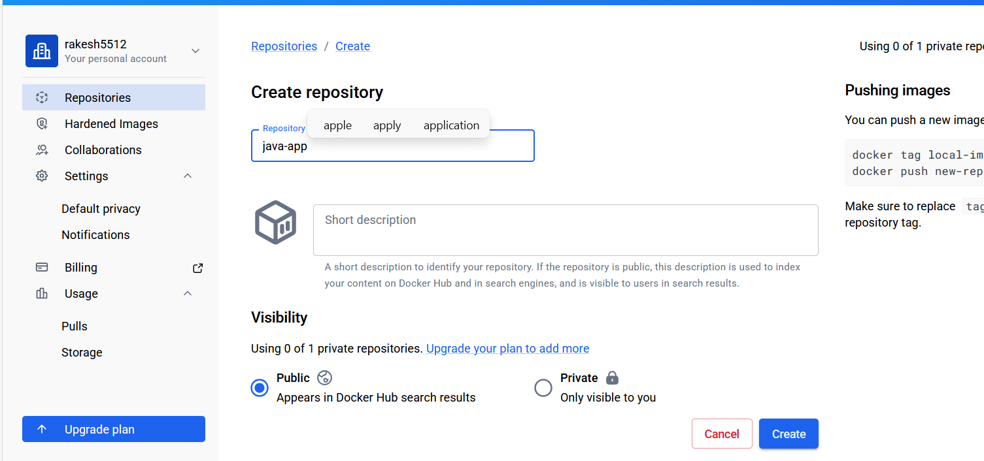
docker tag java-app:v1 rakesh5512/java-app:v1
docker push rakesh5512/java-app:v1
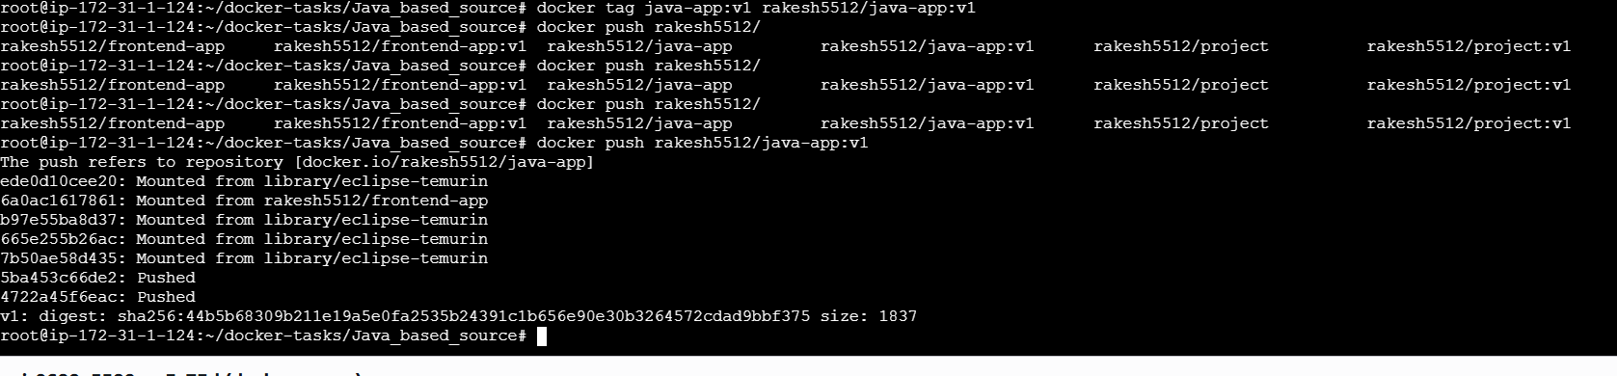
Let check in docker hub if the image has been pushed or not

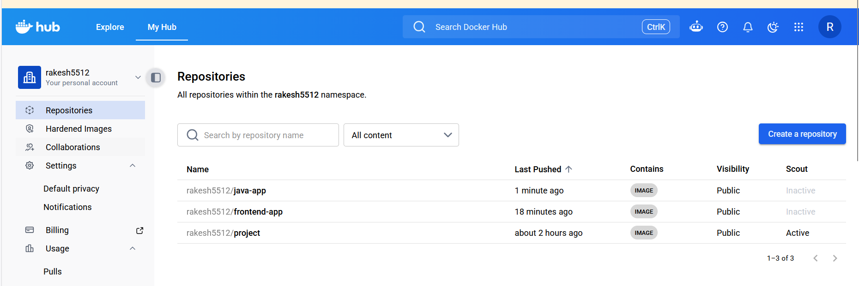

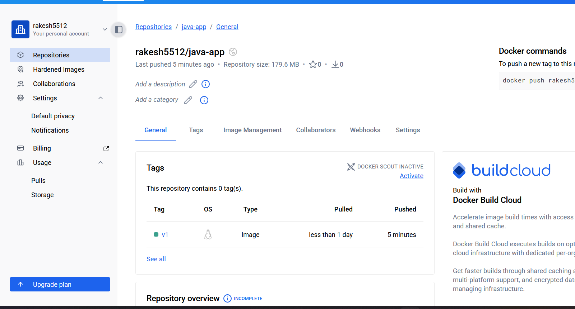
From theNode.js-based source code, write a Dockerfile, build with tagv1, run, and push it to the Docker registry.
Now let’s do the Node.js-based source code properly.
First go into the node.js project:
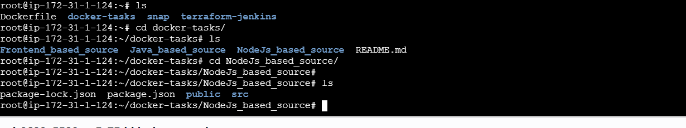
Create a vi Dockerfile
FROM node:18-alpine

WORKDIR /app

COPY package*.json ./

RUN npm install

COPY . .

EXPOSE 3000

CMD ["npm", "start"]
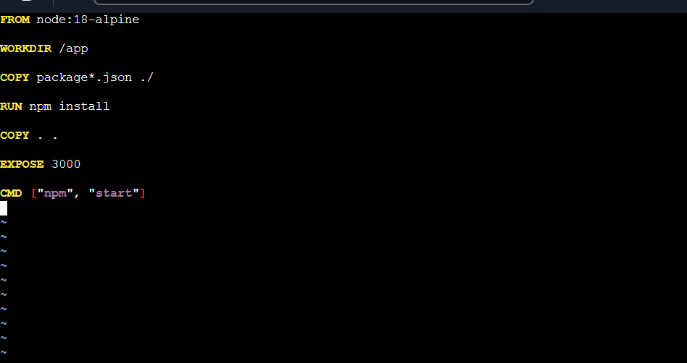

This Dockerfile uses a Node.js image to run the application. First, it creates a working directory called /app inside the container. Then it copies the package.json files and installs all required dependencies using npm install. After installing dependencies, it copies the remaining application files into the container. It exposes port 3000 so the application can be accessed from outside the container. Finally, it starts the Node.js application using the npm start command.

Build Docker Image with tag v1
docker build -t node-app:v1 .

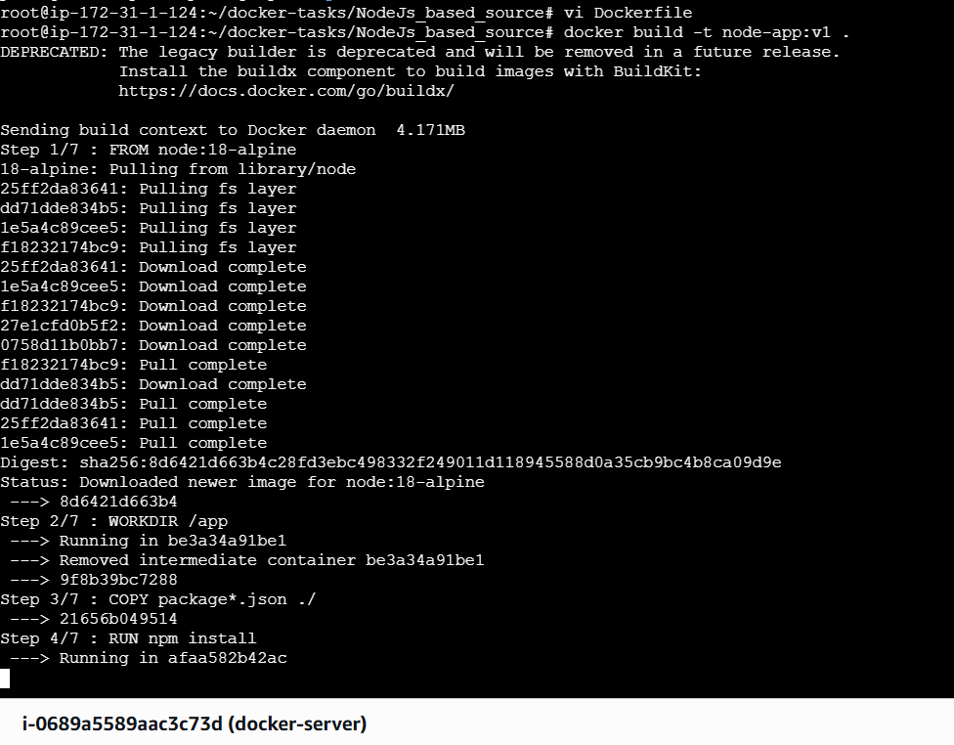

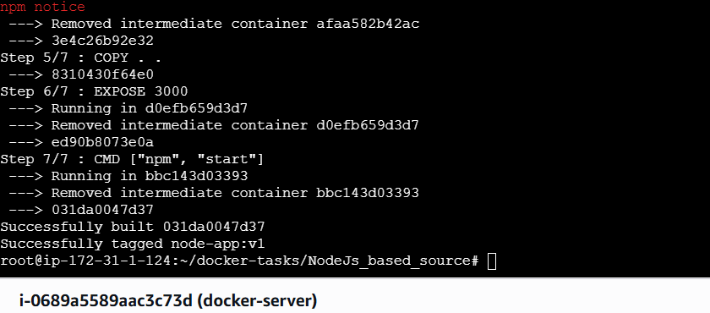
Docker images
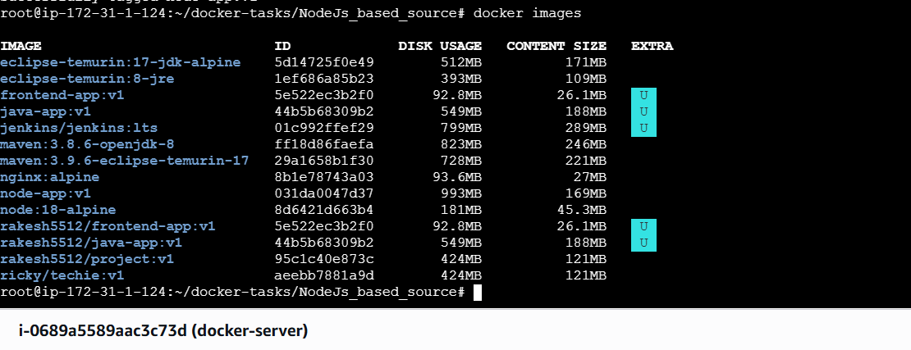
Run the container

docker run -d --name node-container -p 3001:3000 node-app:v1
Docker ps
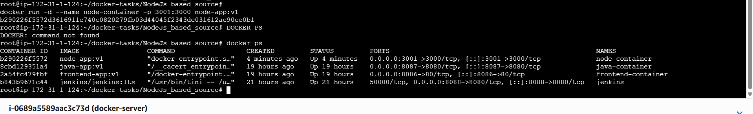

Lets access the browser

Lets push it to DockerHub
Lets create a repo

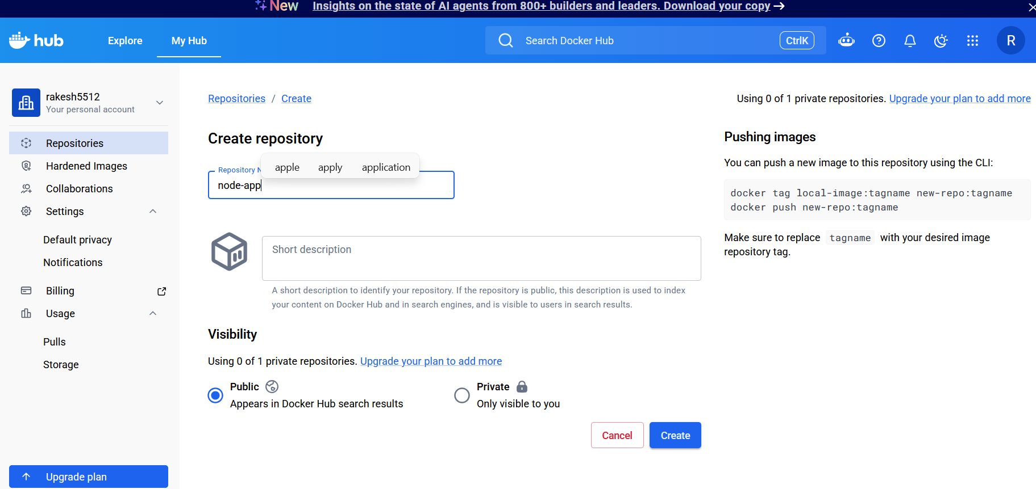
Lets push the image to container

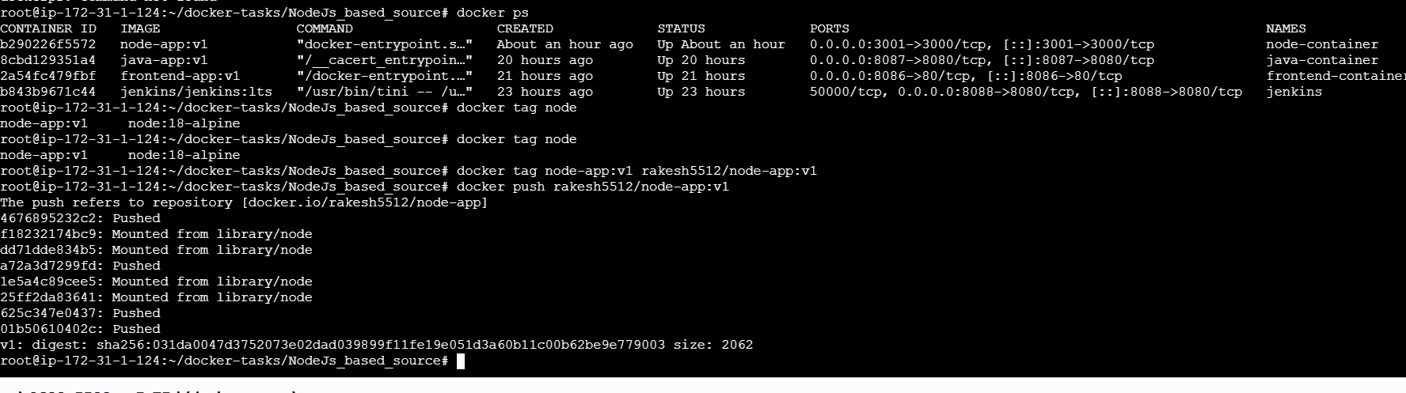

Lets check in DockerHub
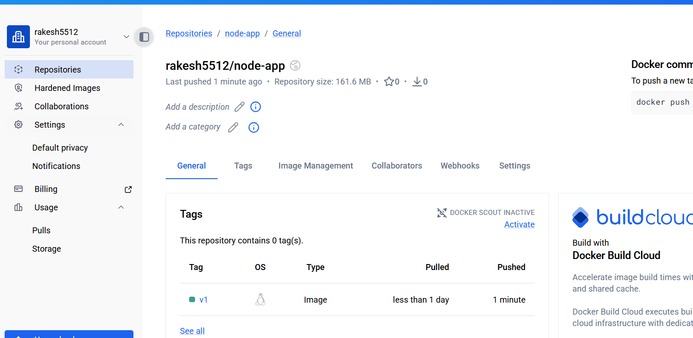
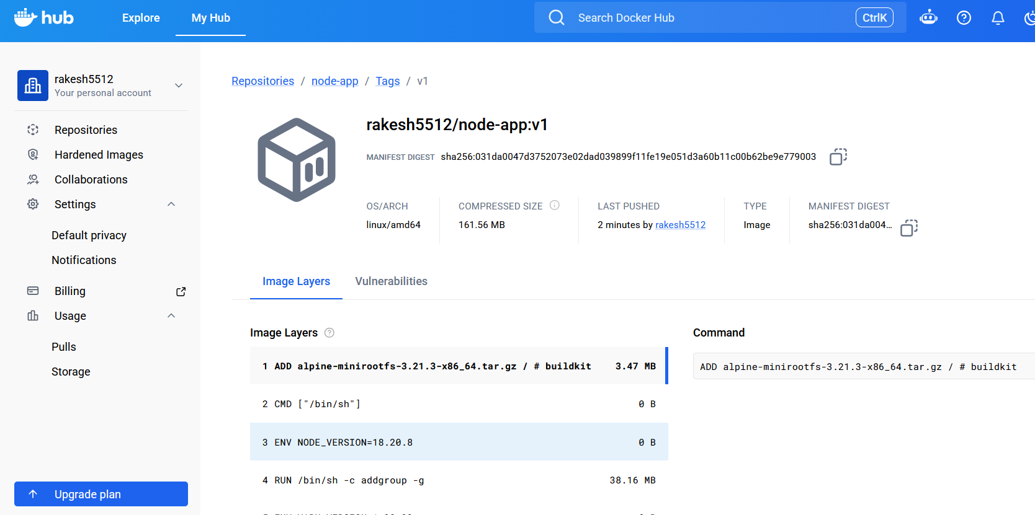
Write a docker-compose file to set up WordPress with a MySQL database.
Create a docker-compose.yml file using command vi
version: '3'

services:
db:
image: mysql:5.7
volumes:
- db_data:/var/lib/mysql
restart: always
environment:
MYSQL_ROOT_PASSWORD: somewordpress
MYSQL_DATABASE: wordpress
MYSQL_USER: wordpress
MYSQL_PASSWORD: wordpress

wordpress:
depends_on:
- db
image: wordpress:latest
ports:
- "8000:80"
restart: always
environment:
WORDPRESS_DB_HOST: db:3306
WORDPRESS_DB_USER: wordpress
WORDPRESS_DB_PASSWORD: wordpress
WORDPRESS_DB_NAME: wordpress

volumes:
db_data:
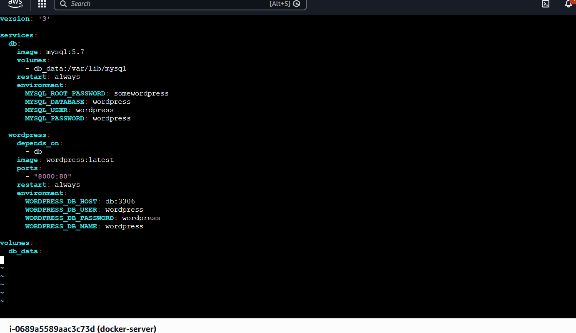
Lets start these services, save the file and run using command
docker compose up

Now lets open in browser publicIP:8000
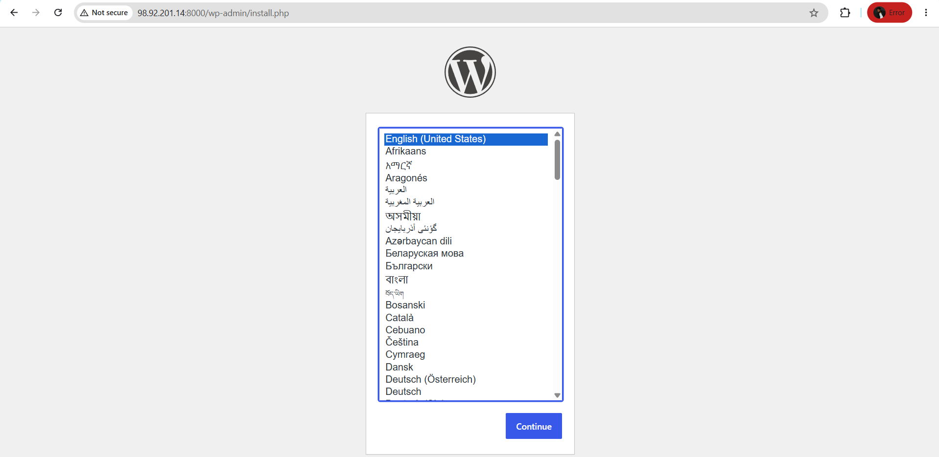
Successfully Installed Word Press
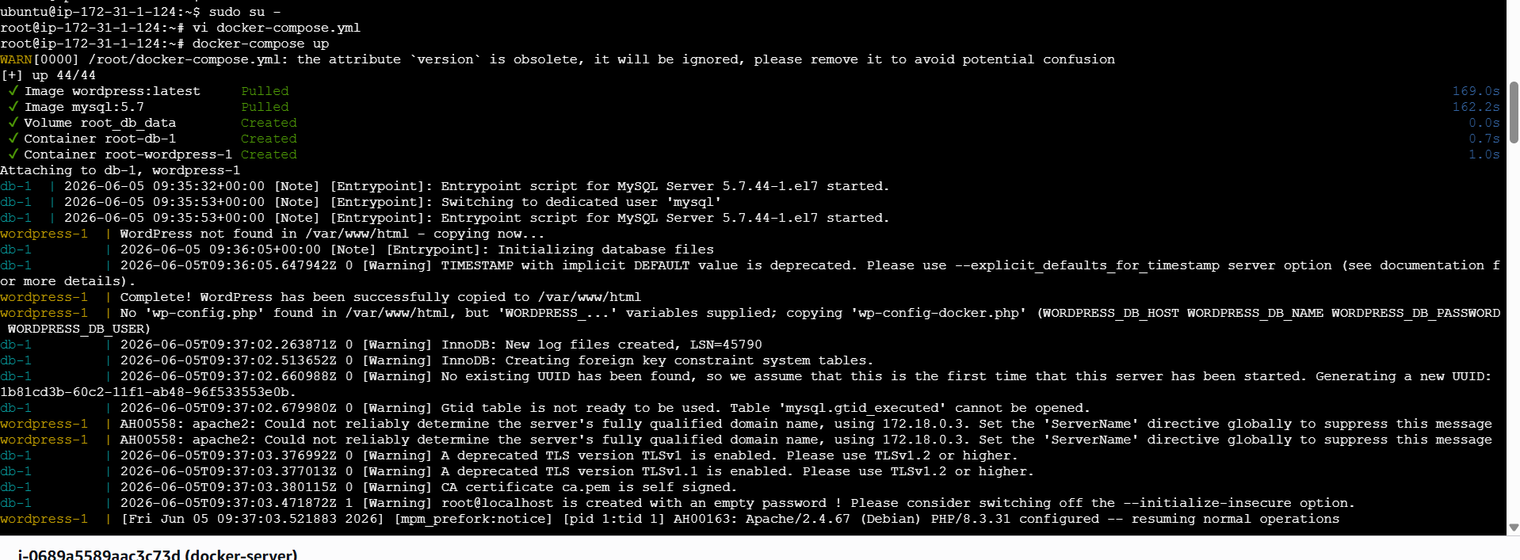

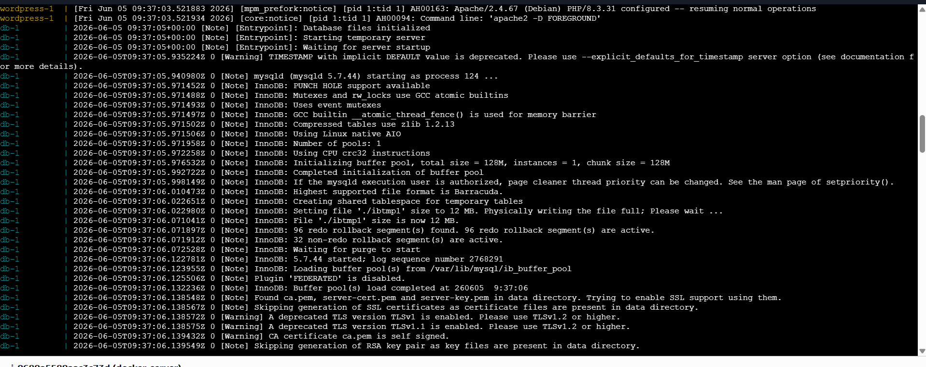
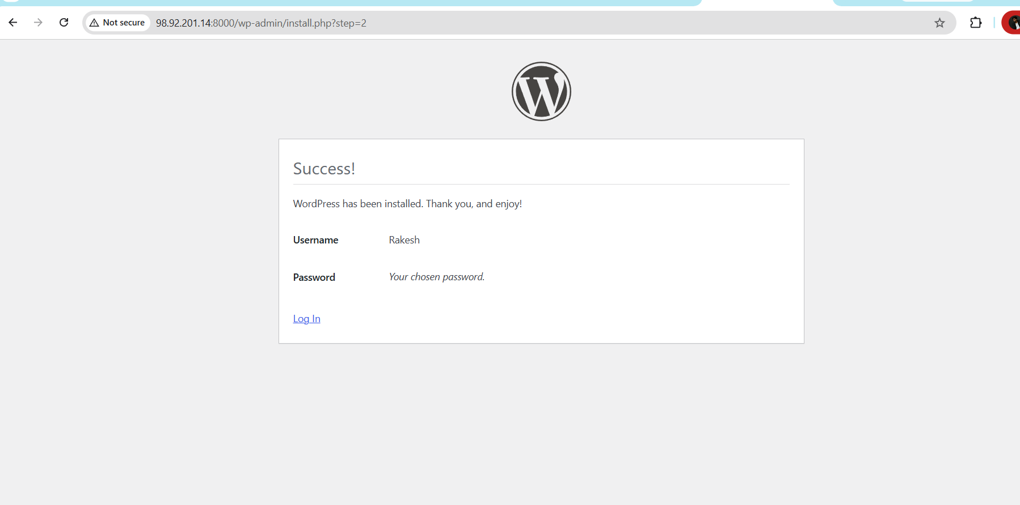
LogIn to WordPress
And we can observe in CLI it starts to install remaining dependencies

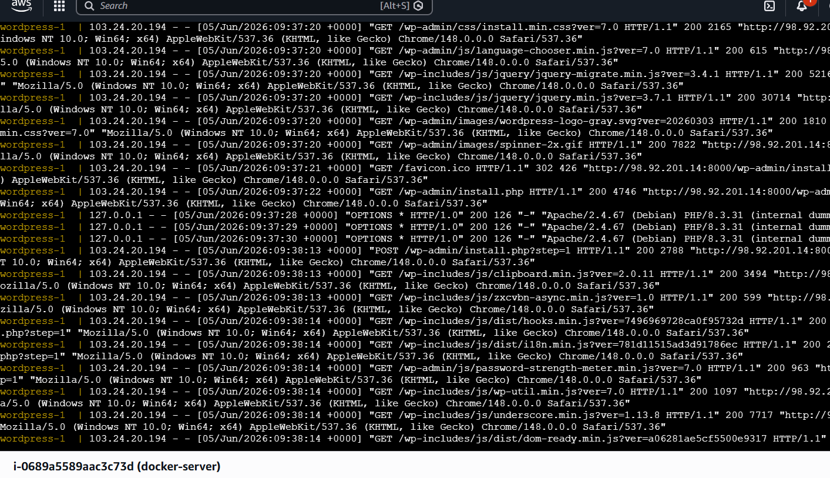
Now if we check in another CLI and do
docker ps
We can see wordpress and mysql are running
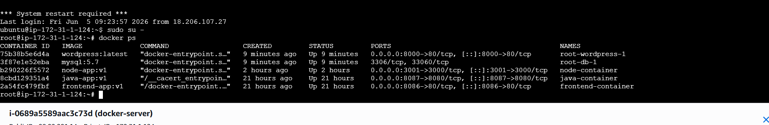
By doing docker-compose ps we can see list of containers running in docker-compose
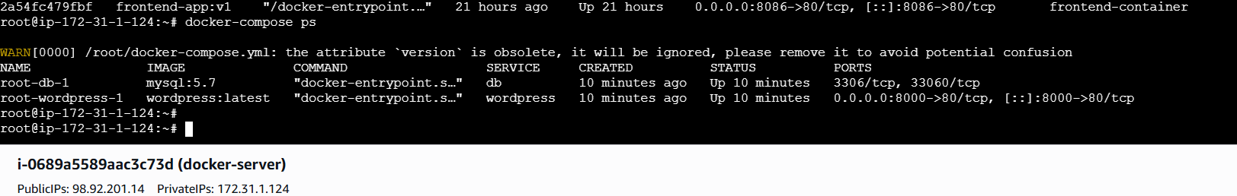

4.Provision one EC2 instance using Terraform and install Jenkins.
Lets Install Terraform first using command
wget -O - https://apt.releases.hashicorp.com/gpg | sudo gpg --dearmor -o /usr/share/keyrings/hashicorp-archive-keyring.gpg
echo "deb [arch=$(dpkg --print-architecture) signed-by=/usr/share/keyrings/hashicorp-archive-keyring.gpg] https://apt.releases.hashicorp.com $(grep -oP '(?<=UBUNTU_CODENAME=).*' /etc/os-release || lsb_release -cs) main" | sudo tee /etc/apt/sources.list.d/hashicorp.list
sudo apt update && sudo apt install terraform
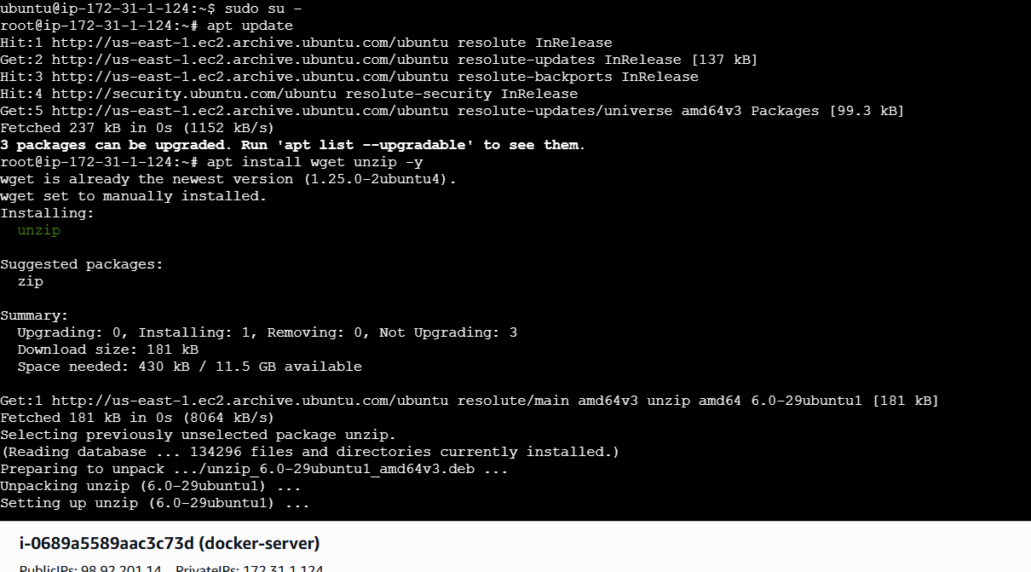
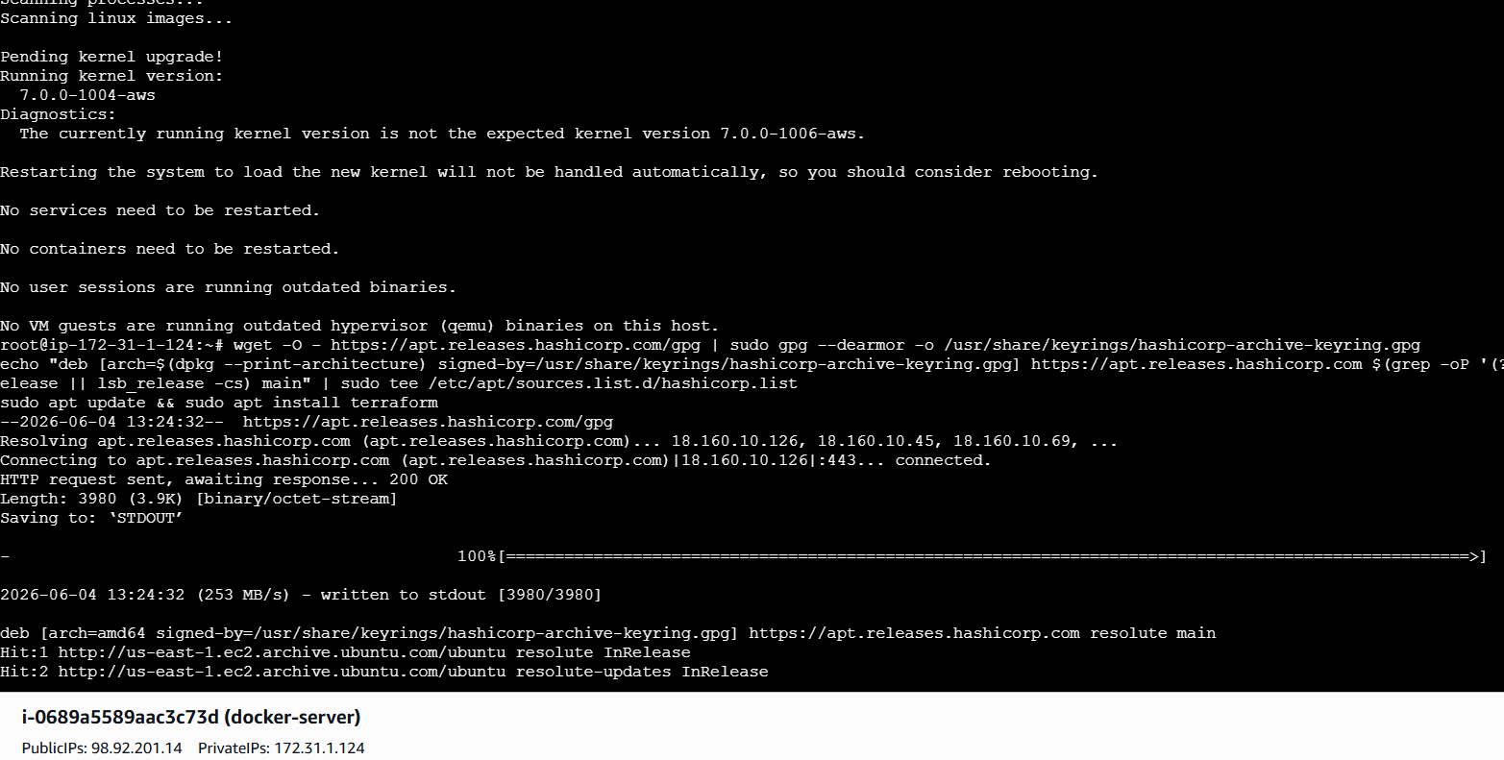
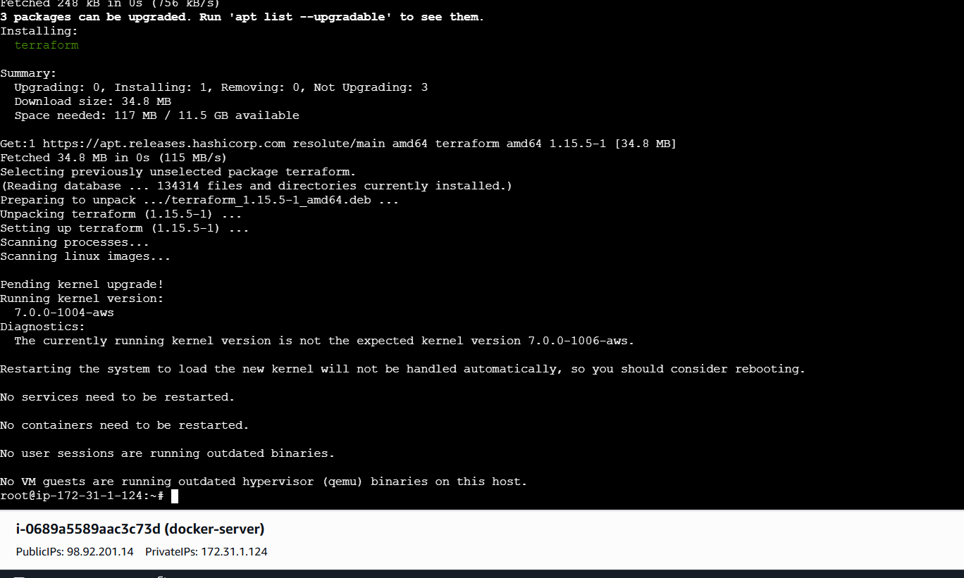
See terraform version
LEts configure awscli use
aws configure
aws sts get-caller-identity ⇒to confirm
Create a directory and changing to that directory i will be using the command
mkdir terraform-jenkins / cd terraform-jenkins

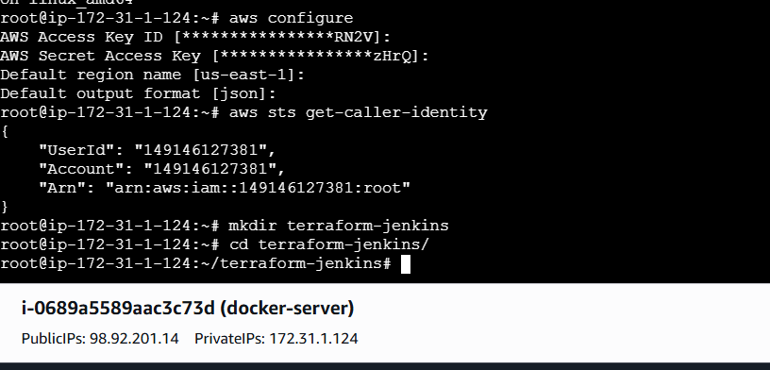
Inside Terraform-jenkins folder lets create some files using
touch main.tf variables.tf terraform.tfvarsuserdata.sh

Lets add userdata for installing jenkins through terraform in userdata
Why are we using user-data?
AWS runs this script automatically during EC2 launch, so Jenkins gets installed without manual steps.

#!/bin/bash
# Update packages
apt update -y
# Install Java 21
apt install openjdk-21-jdk -y
# Create keyrings directory
mkdir -p /etc/apt/keyrings
# Add Jenkins key
wget -O /etc/apt/keyrings/jenkins-keyring.asc \
https://pkg.jenkins.io/debian-stable/jenkins.io-2026.key
# Add Jenkins repository
echo "deb [signed-by=/etc/apt/keyrings/jenkins-keyring.asc] \
https://pkg.jenkins.io/debian-stable binary/" | sudo tee \
/etc/apt/sources.list.d/jenkins.list > /dev/null
# Update packages again
apt update -y
# Install Jenkins
apt install jenkins -y
# Enable and start Jenkins
systemctl enable jenkins
systemctl start jenkins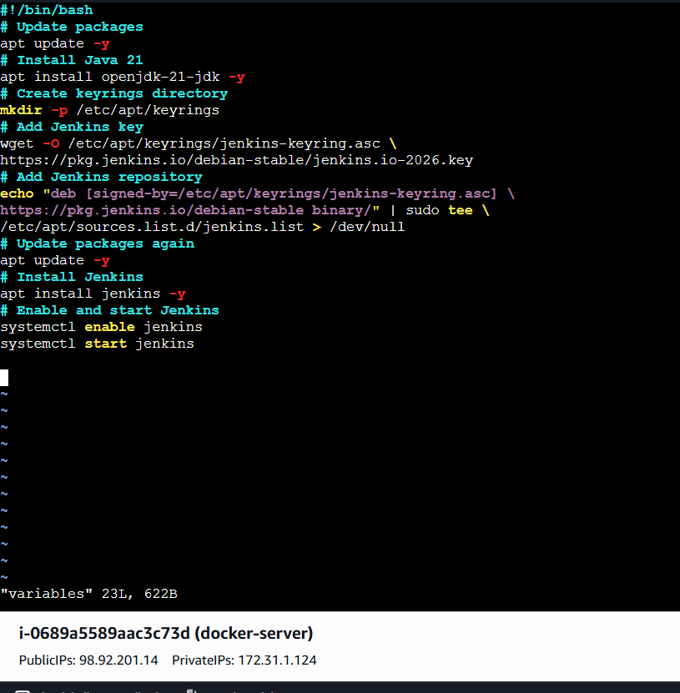

Lets add variables in Create vi variables.tf
variable "aws_region" {
default = "us-east-1"
}

variable "instance_type" {
default = "t3.small"
}

variable "key_name" {
description = "AWS Key Pair Name"
}

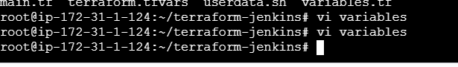
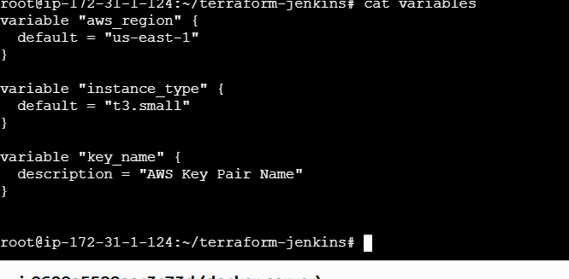

Create terraform.tfvars using vi
key_name = "jenkins.pem"

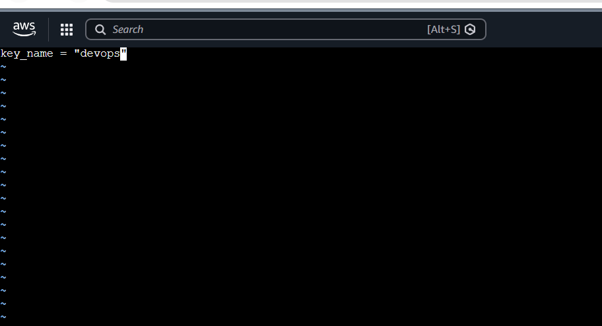
Lets create main.tf using vi
provider "aws" {
region = var.aws_region
}

# Get latest Ubuntu AMI
data "aws_ami" "ubuntu" {
most_recent = true

owners = ["099720109477"]

filter {
name = "name"
values = ["ubuntu/images/hvm-ssd-gp3/ubuntu-noble-24.04-amd64-server-*"]
}
}

# Security Group
resource "aws_security_group" "jenkins_sg" {
name = "jenkins-security-group"

ingress {
description = "SSH"
from_port = 22
to_port = 22
protocol = "tcp"
cidr_blocks = ["0.0.0.0/0"]
}

ingress {
description = "Jenkins"
from_port = 8080
to_port = 8080
protocol = "tcp"
cidr_blocks = ["0.0.0.0/0"]
}

ingress {
description = "HTTP"
from_port = 80
to_port = 80
protocol = "tcp"
cidr_blocks = ["0.0.0.0/0"]
}

egress {
from_port = 0
to_port = 0
protocol = "-1"
cidr_blocks = ["0.0.0.0/0"]
}
}

# EC2 Instance
resource "aws_instance" "jenkins_server" {
ami = data.aws_ami.ubuntu.id
instance_type = var.instance_type
key_name = var.key_name
vpc_security_group_ids = [aws_security_group.jenkins_sg.id]

user_data = file("userdata.sh")

tags = {
Name = "Jenkins-Server"
}
}

# Output Public IP
output "public_ip" {
value = aws_instance.jenkins_server.public_ip
}

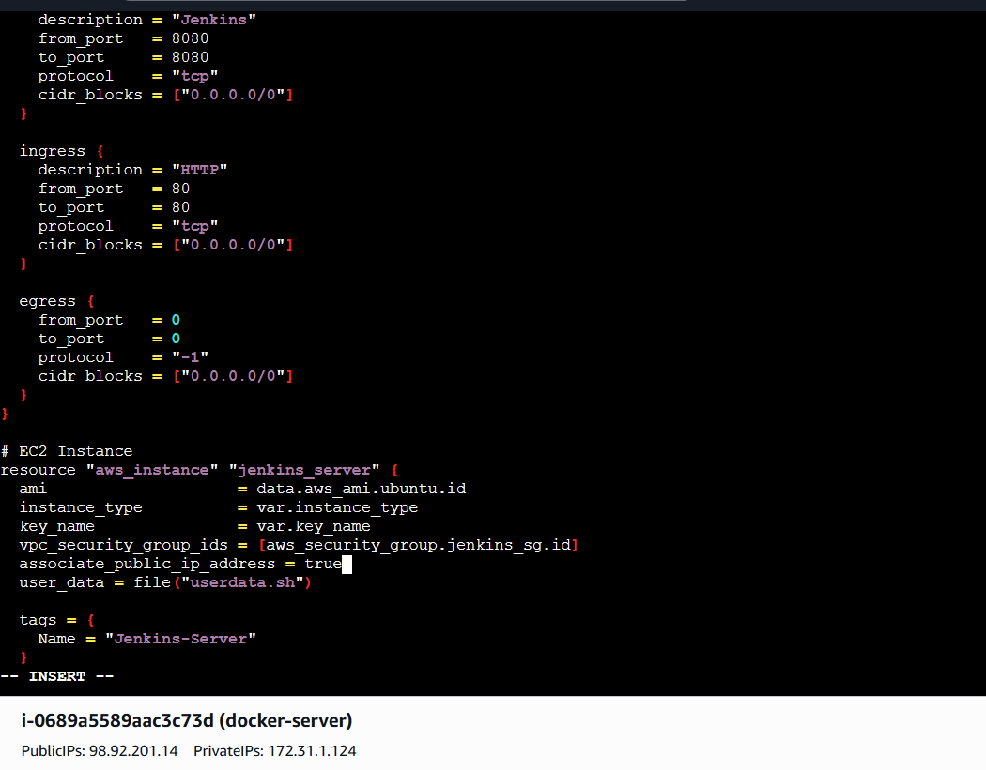
Lets Intilialize terraform using command
What does it does? Downloads AWS provider and Initializes Terraform project

Terraform init
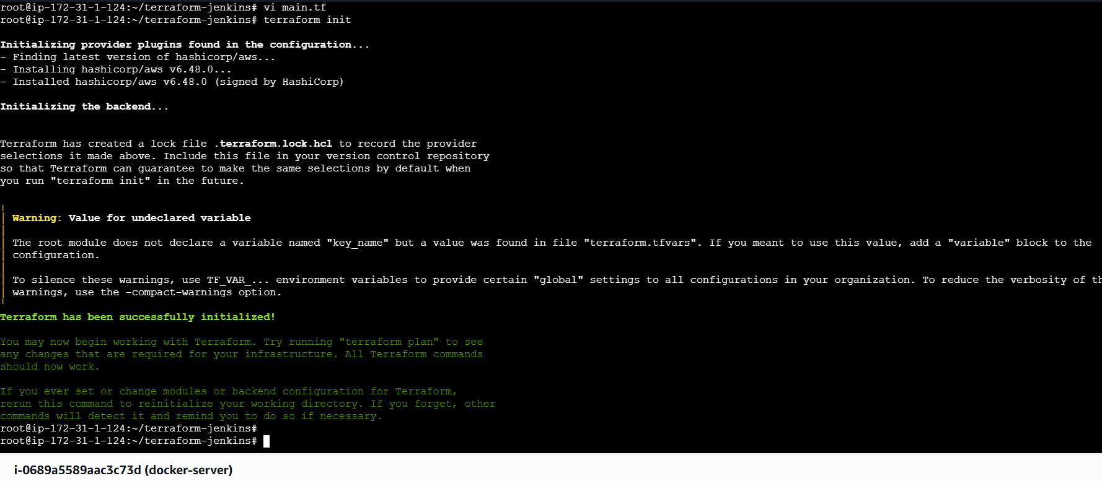
Validating the code using
terraform validate
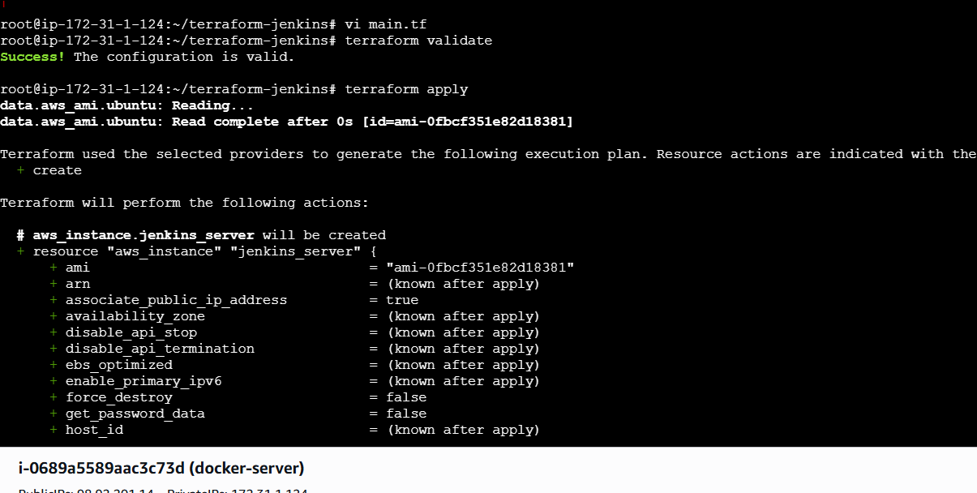

Lets preview the infrastructure using
This shows: EC2 creation and Security group creation

Terraform plan
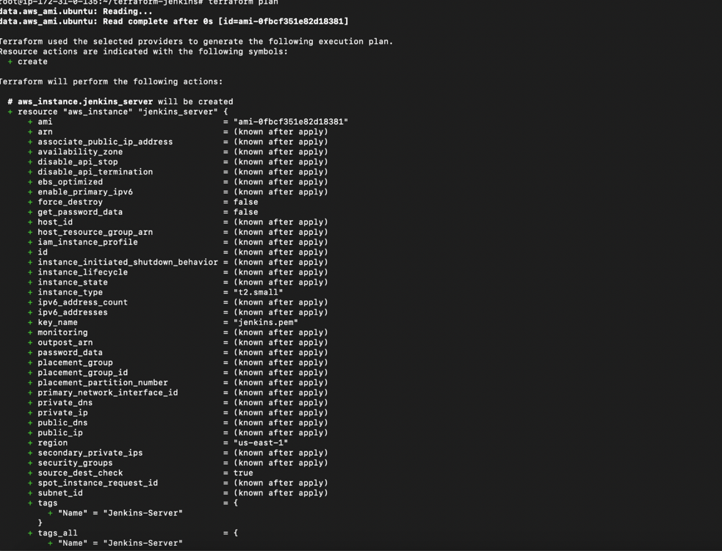

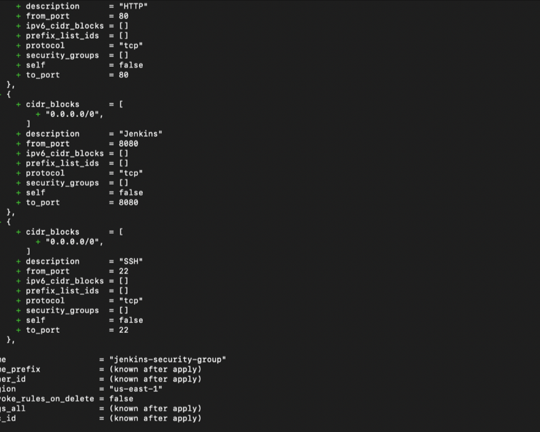

LEts create the Infrastructure now using
terraform apply

It will start create aws instance
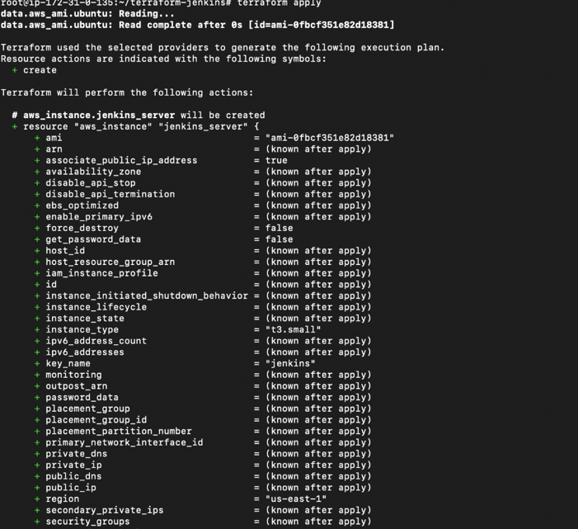

Installing java/jenkins/docker in the instance
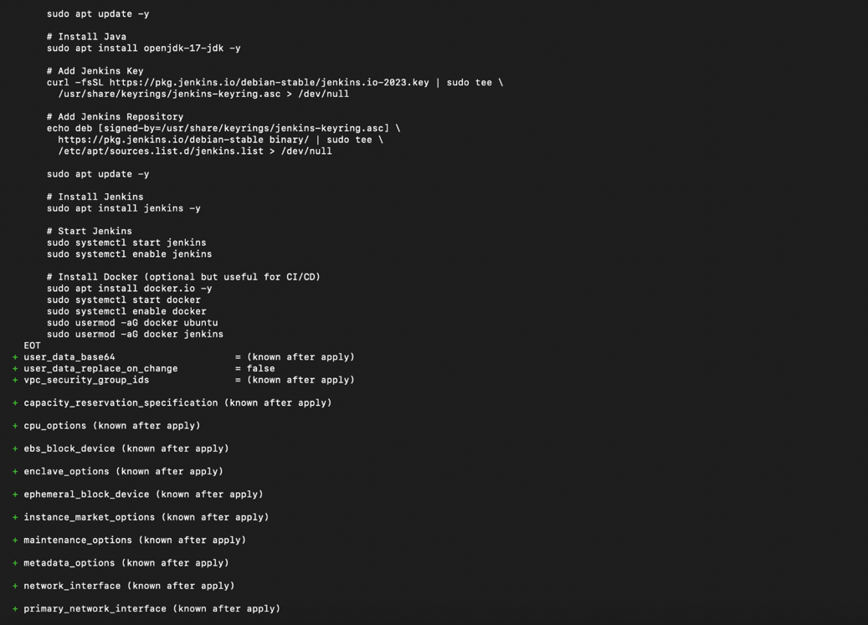

Aws SG and all
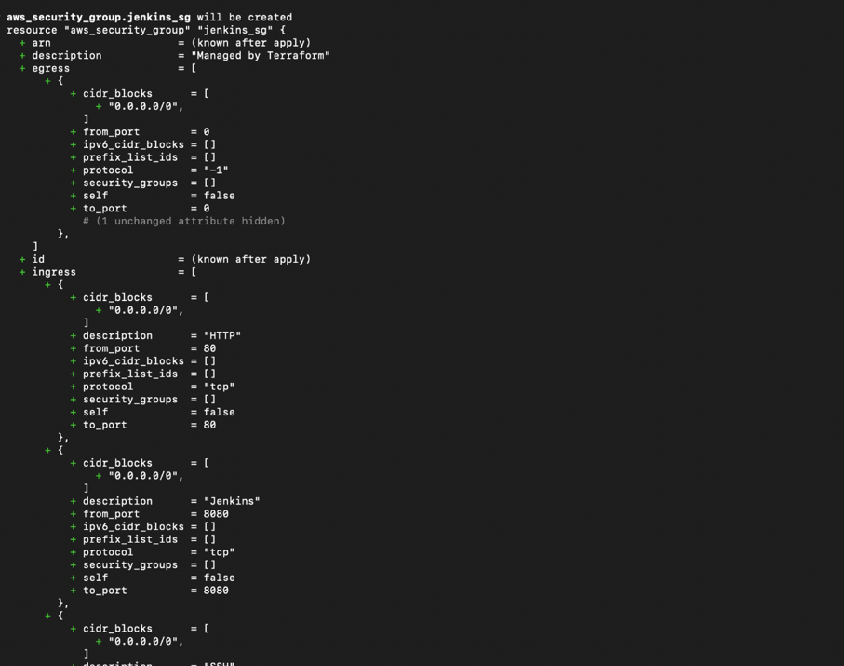

Successfully Created
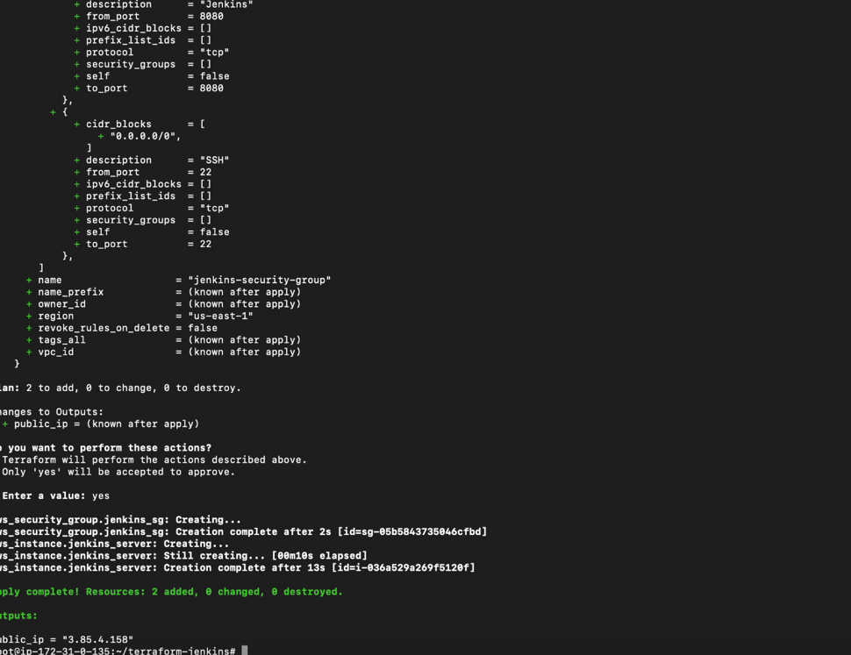
Lets check the output
Terraform output
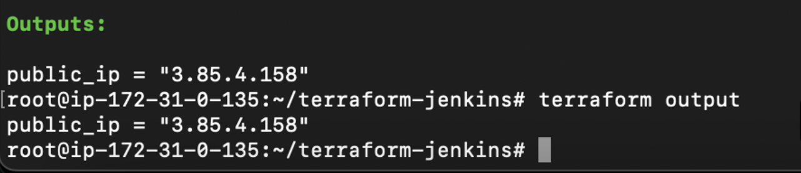
Instance has been created
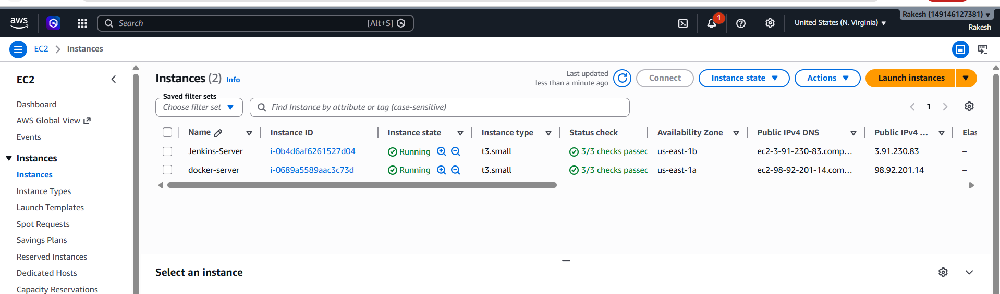

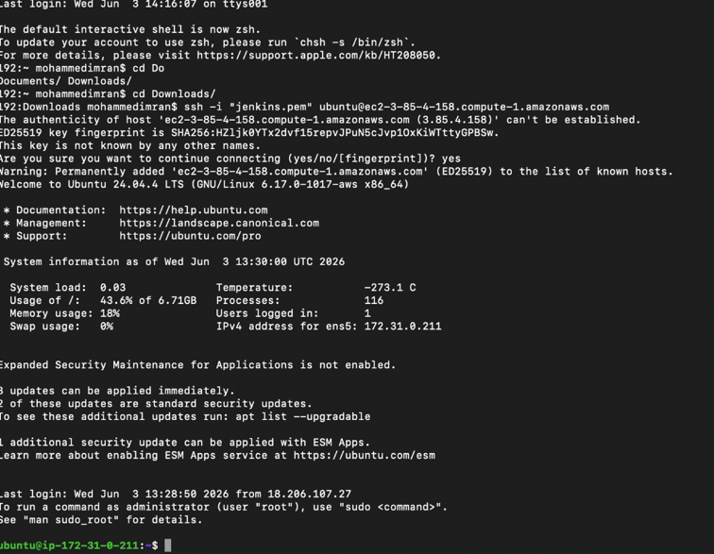
Now lets check if jenkins is working using
publicIP:8080
